SELECT * FROM employees WHERE first_name LIKE 'Y%n';

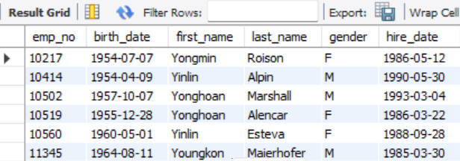

SELECT emp_no, salary * 1.30 AS increased_salary FROM salaries;

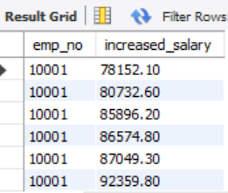

SELECT DISTINCT title FROM titles;



